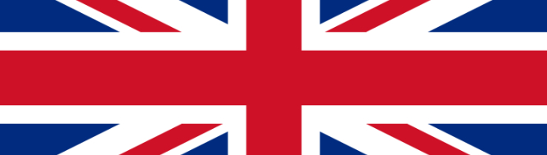
Liverpool – London
British Invasion
September 26 – October 5, 2020
Heartland International Travel & Tours: ITINERARY

Sat. Sept 26, 2020
Depart Winnipeg on Air Canada #268 at 2:45 pm for Toronto where you connect to Air Canada # 1930 at 10:55 pm for your overnight flight to Manchester, England.

Sun. Sept 27, 2020
You arrive at Manchester airport. After clearing customs, you board your Motor Coach and depart for nearby Liverpool. Upon arrival in Liverpool you check in to the Hard Day’s Night Hotel. Coach to Jacaranda Club for a drink and lunch (at own expense). After a short drive take a one hour guided tour of the Casbah Club. Return to the hotel by Coach. Our evening concludes with pre-paid dinner at the William Gladstone Pub. (D)

Mon. Sept 28, 2020
English breakfast at hotel
Drive to the Albert Dock to take the “Ferry Across the Mersey” boat ride before we return to the Albert Docks. Visit the Beatles Story Museum located in the dock. At the end of this fascinating exhibition we take a short lunch break (at own expense). Join the Magical Mystery Tour departing the Albert Docks. This two-hour tour concludes its route at The Cavern Club which we will visit. In the evening there is a pre-paid dinner at the Hard Day’s Night restaurant. Following dinner we are joined by renowned Liverpool music expert and author Spencer Leigh Spencer. He will talk to us about his radio show and his life involved with Liverpool and its rock musicians. If we chose after dinner drinks (at own expense) at the Cavern Pub. (B, D)

Tues. Sept 29 2020
English breakfast at the hotel.
In the morning you visit Mendips and 20 Forthlin Road the childhood homes of John Lennon and Sir Paul McCartney. Lunch on your own
Afternoon – Free to visit more of Liverpool on your own, a great suggestion would be the British Music Experience Museum. Dinner on your own. (B)

Wed. Sept 30, 2020
English breakfast at the hotel
In the morning you depart Liverpool by Motor Coach and to London reaching our hotel in early afternoon.
Later depart hotel by tube to the Sticky Fingers restaurant, Phillimore Gardens, Kensington where we have pre-paid dinner. Return to Lancaster Gate Hotel by tube. (B, D)

Thurs. Oct 01, 2020
English breakfast at hotel
In the mid-morning take the tube to Tottenham Court Road. We have a prepaid lunch at a nearby pub. Following lunch we meet our guide Richard Porter and take the Soho Rock Walk tour, After the tour take the underground to Oxford St and Tottenham Court Road in West End for dinner at restaurant or pub (at own expense) Enjoy a West End Musical Theater evening. Returning by underground to hotel. (B, L)
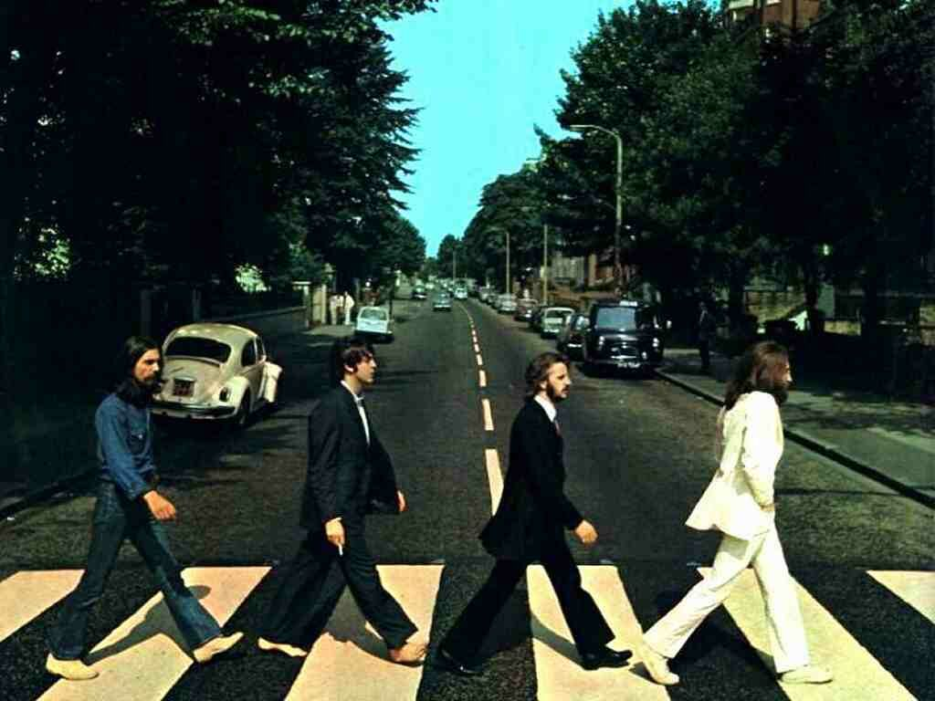
Fri. Oct 02, 2020
English breakfast at hotel
Travel by underground to Victoria Station to take a 3 hour Historic and Modern London Golden Coach guided sightseeing tour of London including St. Paul’s Cathedral and Guard Change. Lunch on own. In the evening enjoy a pre-paid dinner at The Punch Tavern before returning to hotel. (B, D)

Sat. Oct 03, 2020
English breakfast at hotel
Morning is free to visit more of London on your own. Later take underground to Park Lane to Hard Rock Café for a pre-paid lunch at 11:30 am. Tour their vault and gift shop. After lunch take tube to Marylebone Station where we meet our guide Richard Porter at 2:30 pm at the station to take the Beatles “In My Life” Walking tour. After take tube to the hotel. The evening is free to have dinner on your own. (B, L)
Trip Includes
- 3 nights at the Hard Day’s Night Hotel in Liverpool
- 5 nights at the Lancaster Gate Hotel in London
- Full English Breakfast Daily
- 2 group lunches and 5 group dinners (beverages other than coffee are not included with meals)
- All hotel service charges & local taxes
- Oyster Card for underground transportation
- All transfers and site-seeing as shown on itinerary, including admission to attractions and tour guides where applicable.

9 Night Tour Cost in Canadian Funds per person
(Including taxes + fees)
Per person, double occupancy: | $2989.00
Single add | $875.00
*Tour is limited to 25 people
Airfare: Departing from Winnipeg
(including taxes + fees)
Per person | $1336.00
**Airfare from other cities provided upon request
Payment schedule:
$500.00 non-refundable deposit at time of booking
$500.00 non-refundable deposit on/by April 26, 2020
Final payment on/by June 26, 2020
Booking:
Phone: 204-989-9630 or Toll Free 1-866-890-3377
Email: jaydef@heartlandtravel.ca
Fax: 204-989-9636

Sun. Oct 04, 2020
English breakfast at hotel
Morning you depart the hotel on the Classic Rock and Beatles London coach tour. Afterwards return to hotel. Afternoon free to explore London on your own or do some last-minute shopping.
Evening farewell pre-paid dinner at the Leinster Arms.
(B, D)

Mon. Oct 05, 2020
English breakfast at hotel
Passengers departing today meet at reception to transfer to London Heathrow, Terminal 3 to depart on Air Canada #849 3:20pm for your return flight home. Please meet in the lobby with your luggage at 10:30am to find your driver. (B)

*Please note tour schedule subject to change

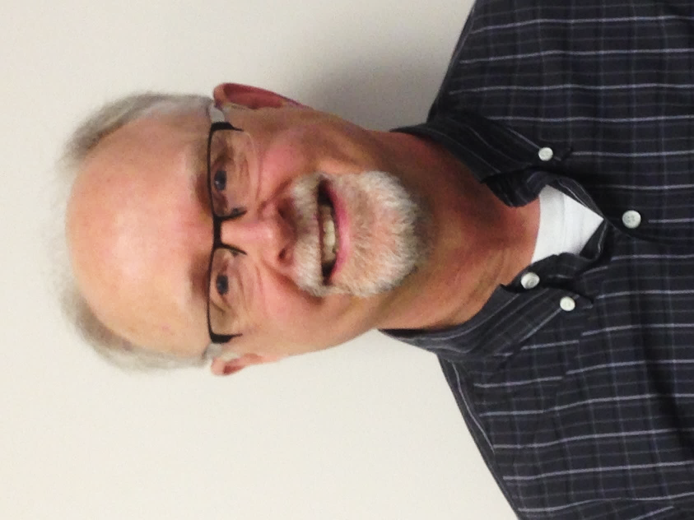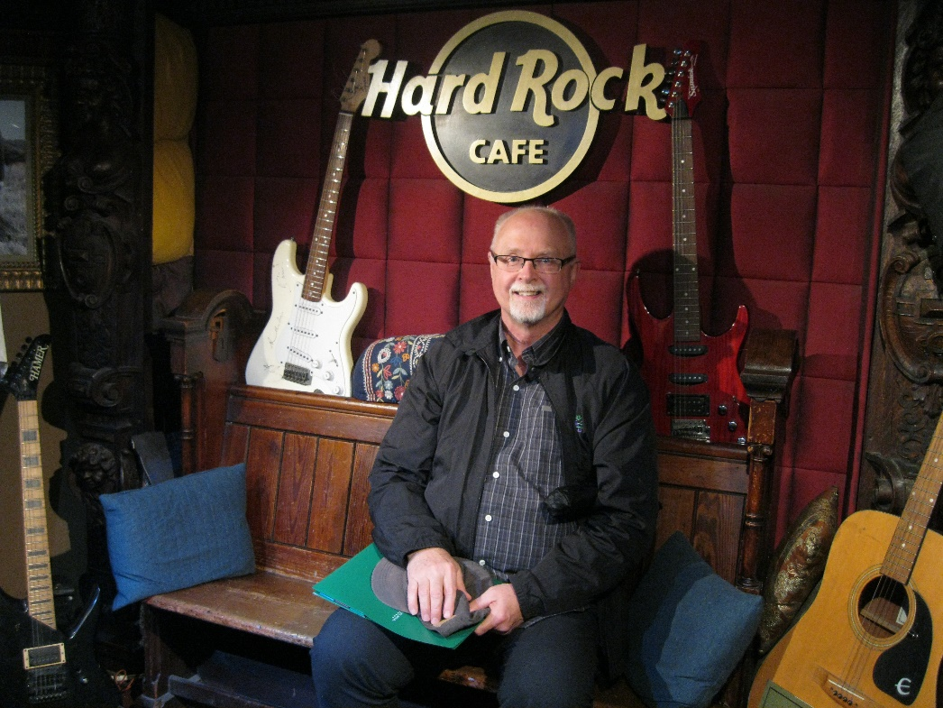

Your Guide is Winnipeg-based music historian, John Einarson.
He is an acclaimed musicologist and award-winning author of 14 music biographies published worldwide. Several of his books have been ranked among the top ten best music biographies.
He received the 2006 ARSC (Association for Recorded Sound Collections) Award for Excellence in Historical Recorded Sound Research.
John has written for Mojo, Uncut, Goldmine, Discoveries, Record Collector, and Classic Rock and is a regular contributor to the Winnipeg Free Press.
He wrote the Juno-nominated Bravo TV documentary Buffy Sainte-Marie: A Multi-Media Life, served as writer/consultant for A&E/Biography Channel’s Neil Young Biography episode, and wrote CBC TV’s The Life & Times of Randy Bachman.
In January 2016, John was the recipient of the Order of the Buffalo Hunt in recognition of his work in preserving Manitoba’s music history. He hosts the popular Magical Musical History Tour of Winnipeg each summer as well as teaching music history classes at McNally Robinson Booksellers and the University of Winnipeg.

As a Beatles and British Invasion expert, John has hosted this Tour in 2010, 2018 and 2019.

2019 Tour Photos