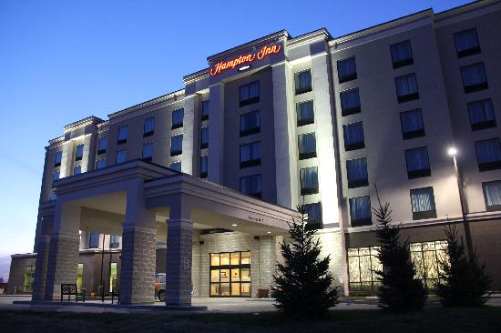
Hampton Inn by Hilton Winnipeg Airport

Just two minutes' drive from James Richardson International Airport, the Hampton Inn by Hilton Winnipeg Airport hotel is surrounded by Fortune 500 companies and offers easy access to downtown Winnipeg. Stay at this hotel if you are traveling on business or to explore the city.

Start your day with Hampton's free hot breakfast. If you're in a rush – simply grab a free Hampton On the Run® Breakfast Bag, available Monday to Friday, for a quick healthy meal to go. Work in the 24-hour business center featuring an array of helpful services and equipment. Reinvigorate with a workout in the fitness center or swim a few laps of the indoor saltwater pool.

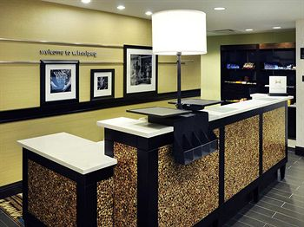
Wind down in a contemporary guest room or suite with a range of thoughtful amenities. Catch up with work using the handy lap desk and stay connected with free high-speed internet access. Watch premium channels on the 37-inch HDTV and enjoy a restorative night's sleep in the clean and fresh Hampton bed™.

Hotel Amenities:
- Automated Teller (ATM)
- Baggage Storage
- Breakfast Area, Complimentary hot breakfast
- Coin Laundry
- Concierge Desk
- Elevators
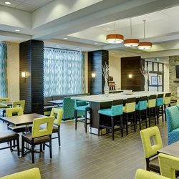
- Foreign Currency Exchange
- Laundry/Valet Service
- Local Area Transportation
- Luggage Hold
- On-Site Convenience Store
- Safety Deposit Box
- Snack Shop
- Fitness Room
- Saltwater pool
- Business Center
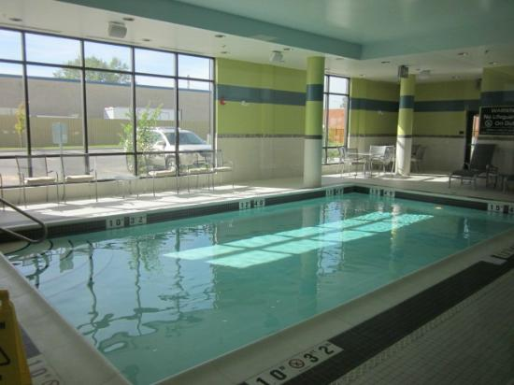
- Business Phone Service
- Complimentary Printing Service
- Express Mail
- Fax
- Photo Copying Service
- Printer
- 100% non smoking
- No pet policy
- Check in: 3pm
- Check out: 11am
- Free parking

Rooms
The standard guest room features clean and fresh Hampton bed ®, LCD flat screen TV with HD Channels, coffee maker, iron with ironing board and free in-room movie channel. Enjoy free high-speed internet access, free buffet style hot breakfast, free coffee and tea in the lobby 24 hours a day and 24-hour front desk message and fax service. Friendly Service, clean rooms, comfortable surroundings, every time.

Room Amenities
Cozy Hampton Bed Braille room numbers
Curved Shower Rod Coffee maker
Duvet Covers Complimentary hot breakfast
Easy to Set Alarm Clock Radio Electronic program guide
Ergonomic Desk Chair Hairdryer
HD Channels High speed internet – no charge
In-Room Movie Channel Iron/ironing board
LCD Flat Panel TV Lap desk
Night Lights in Bathroom Newspaper (Mon-Fri)
On-Demand Movies Purity Basics bath amenities
TV - 40 Inch Flat Panel HD Waterpik(R) Showerhead

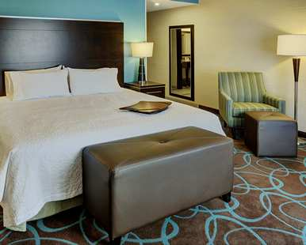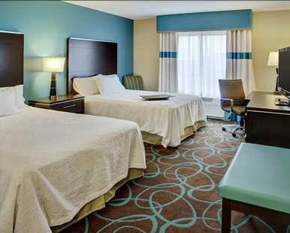

Hotel Address:
730 Berry Street
Winnipeg, MB R3H 0S6
Phone: 204-772-3000

Heartland Travel Special Rates:
$125.00 CAD + taxes per night based on single or double occupancy
1 King bed or 2 queen beds
Additional person in room is $10 / person, up to 4 total

